Experiment no: 03

Experiment name: To develop elementary signals: Unit step signal, Unit Ramp signal, Unit Impulse signal, Exponential signal.
Theory:
Elementary signals serve as the fundamental building blocks in signal processing and linear time-invariant (LTI) system analysis. Any complex arbitrary signal can be represented as a linear combination of shifted and scaled elementary signals. The primary standard test signals include the Unit Step, Unit Ramp, Unit Impulse, and Exponential signals.

1. Unit Step Signal: A signal that transitions from 0 to 1 at a specific time instance t₀.
$$u\left(t - t_{0}\right)=\left\{\begin{aligned}1, t ≥t_{0} \\ 1, t < t_{0}\end{aligned}\right.$$
(Configured with step time t₀ = 2s, changing from 0 to 1)

2. Unit Ramp Signal: A signal that increases linearly with time at a constant slope m.
$$r\left(t\right)= m.\left(t – t0\right). u\left(t - t0\right)$$
(Configured with slope m = 2, start time t_0 = 0 s, giving r(t) = 2t)

3. Unit Impulse Signal: A discrete sequence that has a value of 1 at a single sample point and 0 elsewhere.
$$δ\left[n - n_{0}\right]= \left\{\begin{aligned}1, n = n_{0} \\ 0, n ≠n_{0}\end{aligned}\right.$$
(Configured with a delay of 3 samples, producing a pulse at t = 3 s)

4. Exponential Signal: A signal whose amplitude changes exponentially over time.
$$x\left(t\right)= e^{αt}$$
(Configured using a Clock block, Gain of $α$ = -5, and Math Function block $e^{u}$ to generate the decaying signal $x\left(t\right)=e^{-}5t$)

DSP tools: MATLAB 2019: Simulink Model
Required Blocks
- Step
- Ramp
- Discrete Impulse
- Clock
- Gain
- Math Function
- Scope

Simulink Model:
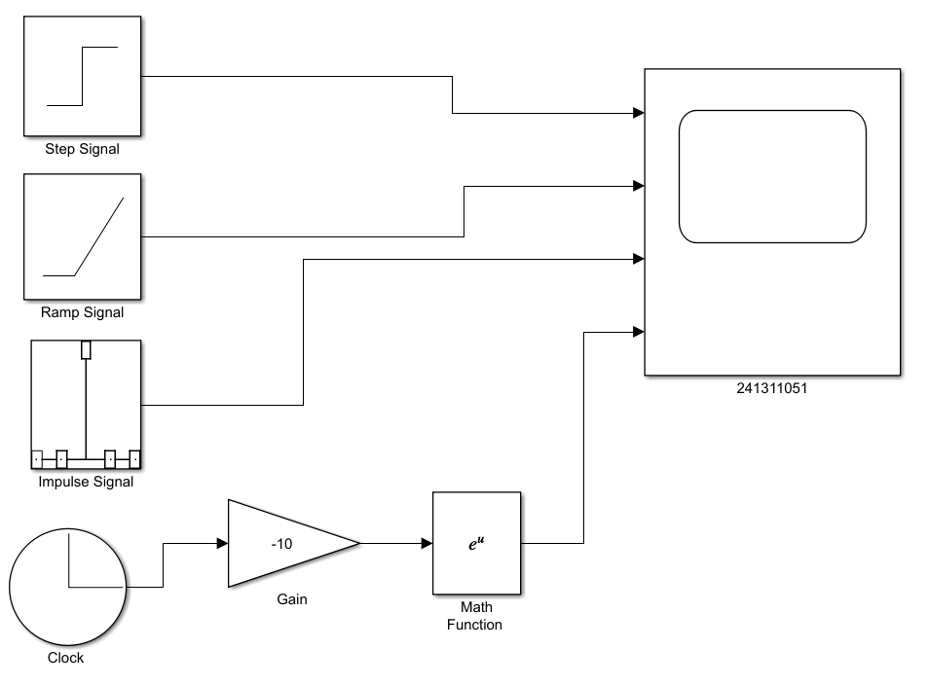

Fig: Simulink Model to generate Step, Ramp, Impulse & Exponential Signal

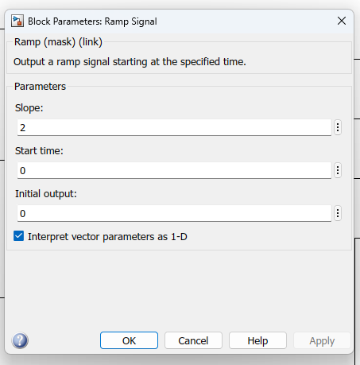
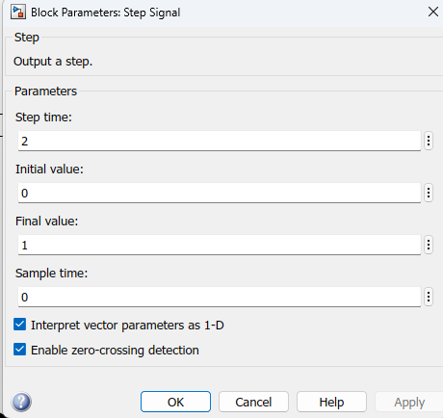
Parameters:

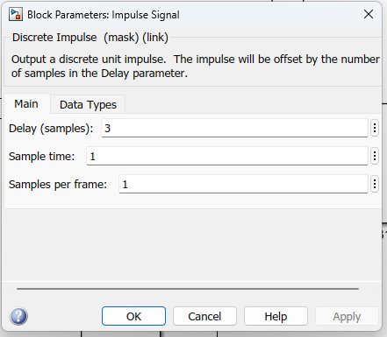
Fig: Step Signal Parameter
Fig: Step Signal Parameter
Fig: Ramp Signal Parameter
Fig: Impulse Signal Parameter
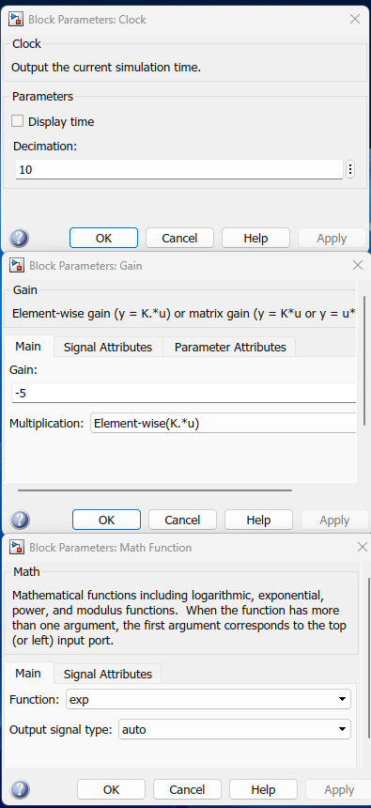

Fig: Exponential Signal Parameter
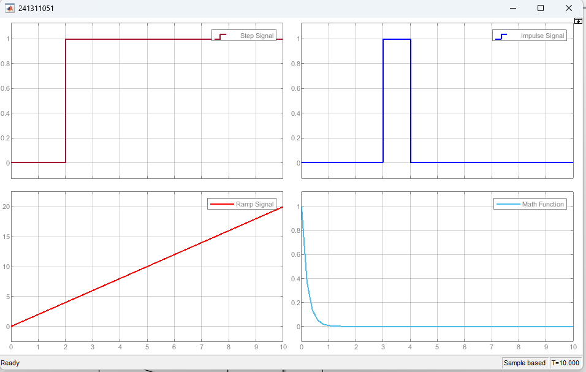
Scope Output:

Fig: Scope Outptut
RESULT & DISCUSSION
Result:
The four elementary signals were successfully generated in MATLAB/Simulink:
Step Signal: Successfully switched from 0 to 1 at t = 2 s.
Impulse Signal: Produced a single unit pulse of amplitude 1 at t= 3 s.
Ramp Signal: Increased linearly from 0 to 20 over 10 seconds with a slope of 2.
Exponential Signal: Started at 1 and rapidly decayed to 0.

Discussion:
Step Signal: The waveform verified the delayed unit step formula:
$$u\left(t - 2\right)=\left\{\begin{aligned}1, t ≥2 \\ 1, t < 2\end{aligned}\right.$$
The signal stayed at 0 before 2 seconds and jumped to 1 at t = 2 s.
Ramp Signal: The output matched the linear equation: r(t) = 2t
Since the slope was set to 2, the signal value reached 20 at t = 10 s (calculated as 2 * 10 = 20).
Impulse Signal: Setting a sample delay of 3 created a discrete pulse at t = 3 s, satisfying:
$$δ\left[n - 3\right]= \left\{\begin{aligned}1, n = 3 \\ 0, n ≠3\end{aligned}\right.$$
The output was 1 only at sample 3 and remained 0 for all other times.
Exponential Signal: Multiplying time by a gain of -5 and passing it through the exponential block produced the decaying curve: $x\left(t\right)= e^{-5t}$
Because the power is negative (-5t), the value drops quickly from 1 at t = 0 toward 0.

PRECAUTIONS
- Proper block parameters, including step time, slope, and sample delays, were accurately set before running the simulation.
- The discrete impulse block sample time was matched with the system simulation step to prevent signal distortion.
- The gain value for the exponential signal was carefully selected with a negative sign to ensure proper decay rather than unbounded growth.
- All connections between the source blocks and the multi-channel scope were verified to prevent signal mismatching.
- The total simulation stop time was set adequately to allow full visualization of all signal transitions and steady-state responses.

